Will it rain in Cardiff this weekend   
for PyCon UK?



Have you ever looked at the weather forecast on your phone and wondered how they know if it is going to rain or be sunny?

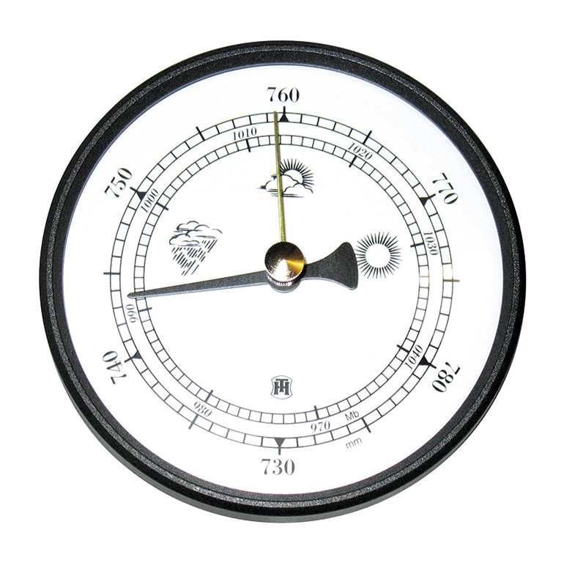

There are many tools that meteorologist use to forecast the weather and one of them is to look at the air pressure.

|  |  |
| --- | --- |
|  |  |
| If the air pressure is high we can predict clear skies, light winds and bright weather. | If the air pressure is low we can predict we are in for cloudy and wet weather. |

If the air pressure starts to drop we can predict a change in the weather and we might need to get out our rain coat and umbrella.

Using the Raspberry Pi and SenseHat we can measure the current air pressure and use the measurement to forecast the weather.

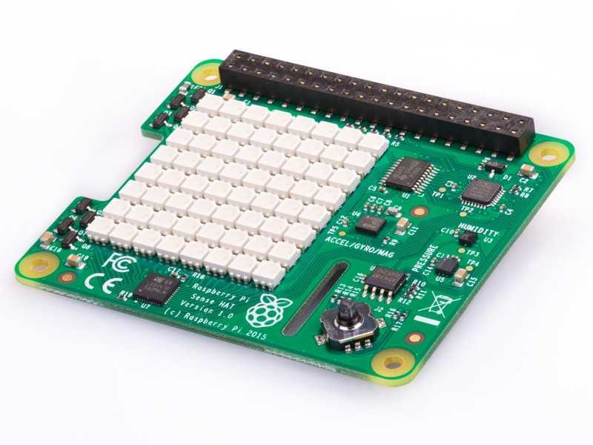

If you don’t have a SenseHat you can still use the SenseHat emulator to try this activity.

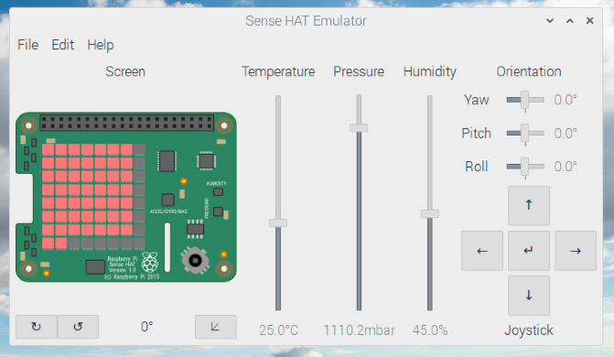

Getting started:

Start mu and select a new blank file.

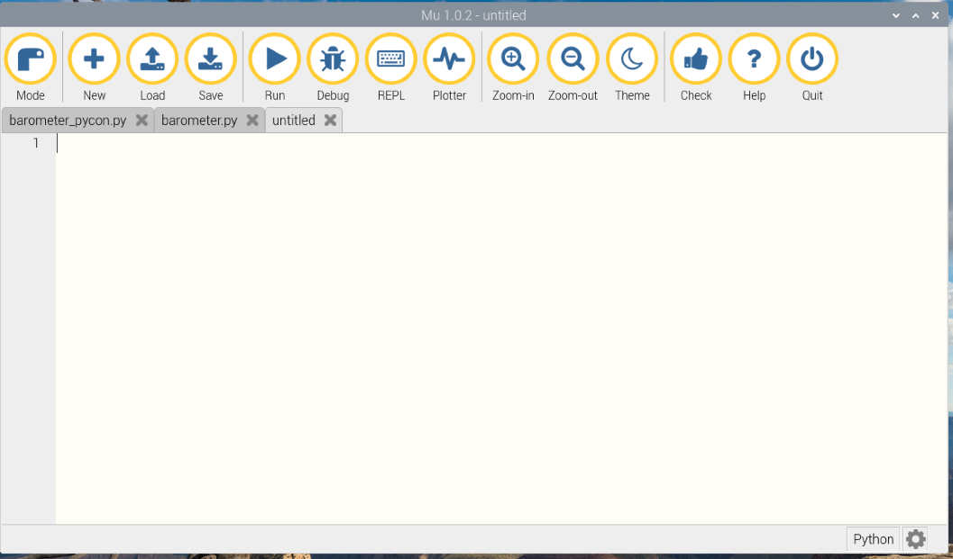

Carefully type in the following code:

|  |  |
| --- | --- |
| If you are using the real SenseHat | If you are using the SenseHat emulator |
| from sense_hat import SenseHat  from time import sleep  sense = SenseHat()  r=[255,0,0]  wait = 10  sense.clear() | from sense_emu import SenseHat  from time import sleep  sense = SenseHat()  r=[255,0,0]  wait = 10  sense.clear() |

The SenseHat has a range of sensors include an air pressure sensor.

We can easily take a measurement of the air pressure with:

pressure = sense.pressure

print (pressure)

When you run the code you will get the actual air pressure with the SenseHat or the value from the air pressure slider on the emulator.



The value is returned in units called millibars (mbar)

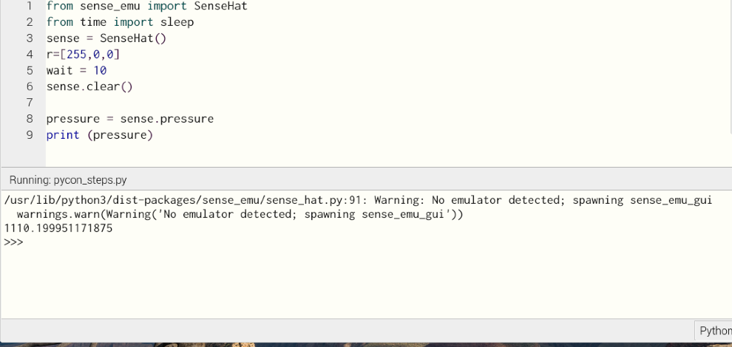

If you are using the emulator you will get an error message – don’t worry about this!

You might have also noticed that you also get about 10 numbers after the decimal point, normally we would tidy this up bit we won’t need to for this activity as we won’t be reading the numbers.

Collecting data:

Add the final block of code starting “while True:”, take care of the tabs

from sense_emu import SenseHat

from time import sleep

sense = SenseHat()

r=[255,0,0]

wait = 10

sense.clear()

pressure = sense.pressure

print (pressure)

while True:

for c in range (0,8):

pressure = sense.pressure

graph_pressure = int(pressure / 150)

for i in range(graph_pressure):

sense.set_pixel(c,i,r)

sleep(wait)

sense.clear()

Running the code:

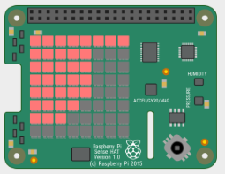

low air pressure

high air pressure

If you are running the emulator you can change the value of the air pressure and watch it on the display.

You can change the frequency at which the samples are taken by changing the value of wait. Initially it will sample every 10 seconds.

wait = 10

Adding colour to the display:

We can easily change the colour of the pixels on the SenseHat display. So far we have only used the colour red.

Add the following two lines of code towards the top of the code.

g=[0,255,0]

b=[0,0,255]

We now need to change the colour depending on the air pressure. Add the following lines with the box around it and make the change for the last line.

while True:

for c in range (0,8):

pressure = sense.pressure

graph_pressure = int(pressure / 150)

for i in range(graph_pressure):

if i<=2:

colour = b

if i>2:

colour = g

if i>5:

colour = r

sense.set_pixel(c,i,colour)

sleep(wait)

sense.clear()

Improving the barometer

The SenseHat can measure a wide range of pressures and we are only interested in a small range of pressures when looking at the weather.

|  |  |  |  |  |
| --- | --- | --- | --- | --- |
| 970 – 990 | 990 – 1000 | 1000 – 1020 | 1020 – 1030 | 1030 above |
| Stormy | Rain | Normal | Fair | Very dry |

We can now use if … statements to look at the pressure

from sense_hat import SenseHat

from time import sleep

sense = SenseHat()

r=[255,0,0]

g=[0,255,0]

b=[0,0,255]

wait = 180

sense.clear(0,0,0)

while True:

for c in range (0,8):

pressure = sense.pressure

print (pressure)

graph_pressure = 0

if pressure >=970 and pressure <991:

print ("Stormy weather")

colour = b

graph_pressure =2

if pressure >=991 and pressure <1000:

print ("Rain on the way")

colour = b

graph_pressure =4

if pressure >=1000 and pressure <1020:

print ("Normal")

colour = g

graph_pressure =5

if pressure >=1020 and pressure <=1031:

print ("Fair")

colour = r

graph_pressure =6

if pressure >=1031 and pressure <=1060.9:

print ("Very dry")

colour = r

graph_pressure =6

for i in range(graph_pressure):

sense.set_pixel(c,i,colour)

sleep(wait)

sense.clear()